**HANDS-ON IIF CONDITION, STORED PROCEDURE & VIEWS —------------------------------------------------------------------------------------------------------------------**

**Tables: Features, Sales, Stores**

| **IIF()**  **The IIF condition accepts three parameters.**   1. **CONDITION** 2. **TRUE** 3. **FALSE**   **IIF (Condition, TRUE statement, FALSE statement)** |
| --- |

**1. Create a Store_Status column in the Sales to check whether the Store is open or closed.**

Select *, IIF(IsHoliday ='TRUE', 'Open','Closed') as Store_Status

from Sales

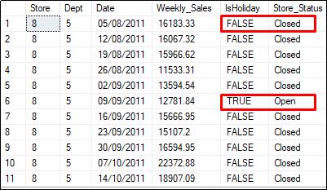

| **VIEW:**  A View is just like a real table. The views are generally referred to as a virtual table. |
| --- |

**2. Create a view to include the Store_Status column.**

**// View Creation**

create view Store_Status_View as

Select *, IIF(IsHoliday ='TRUE', 'Open','Closed') as Store_Status

from Sales

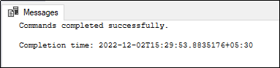

**// To view the View**

select * from Store_Status_View

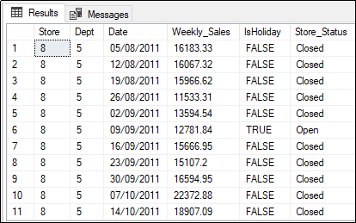

| **STORED PROCEDURE:**  The Stored Procedure can be created once and re-used many times The Stored Procedure will also accept the parameters. |
| --- |

**3. Create a Stored Procedure to estimate the 10 % increase in fuel price.**

**// Stored Procedure Creation without Parameter**

**CREATE PROCEDURE Proc_Fuel_Price as**

**Select Fuel_Price, Fuel_Price+(Fuel_Price + 10)/100 as Estimate_Increase**

**from Features**

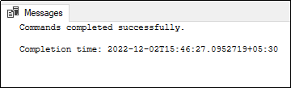

**// Calling Stored Procedure**

**Exec Proc_Fuel_Price**

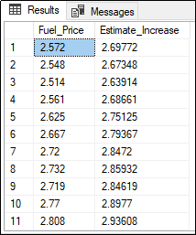

**4. Create a Stored Procedure to check whether the Weekly_Sales is greater than the user’s Sales value.**

**//Stored Procedure created with Parameter (with float data type)**

CREATE PROCEDURE Proc_Weekly_Sales @Sales float as

Select Date,Weekly_Sales from Sales

Where Weekly_Sales > @Sales



**// Calling Stored Procedure**

**Exec Proc_Weekly_Sales @Sales = 1500**

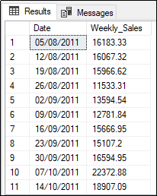

**5. Create a Stored Procedure to fetch the Store details based on the Storetype.**

**//Stored Procedure created with Parameter (with varchar data type)**

CREATE PROCEDURE Proc_Type @type varchar(10) as

Select * from Stores

where Type=@type



**// Calling Stored Procedure**

Exec Proc_Type @type ='C'

